**EXPERINMENT 2**

**Aim :** To study arithmetic and logical operations on images, log transformation and power law transformation.

* **Exercise :**

1. **In a survaillance system, two frames of the captured videos are given as image '1.jpg' and '2.jpg' Apply image subtraction to locate the foreground**.

* **Solution :-**

Code :

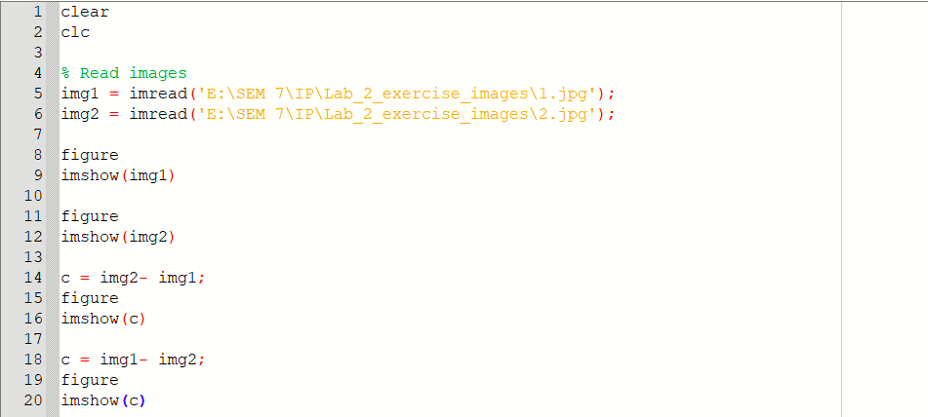

Input Images :

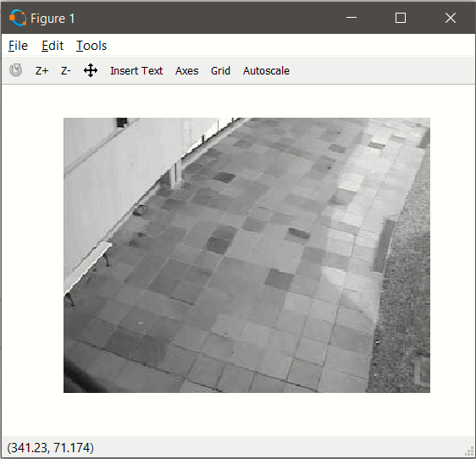

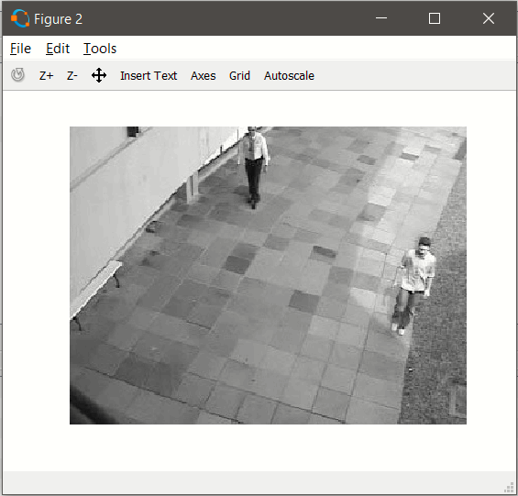

Output Images :

Img2 – Img1

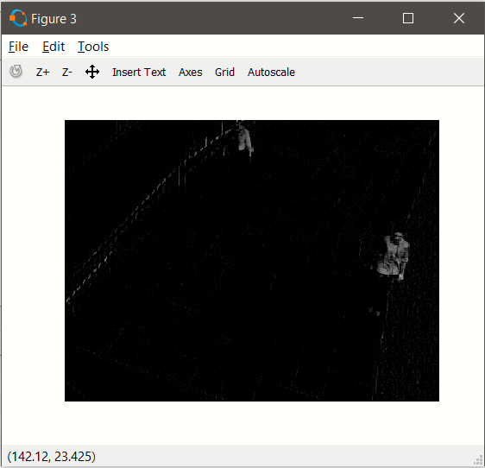

Img1 – Img2

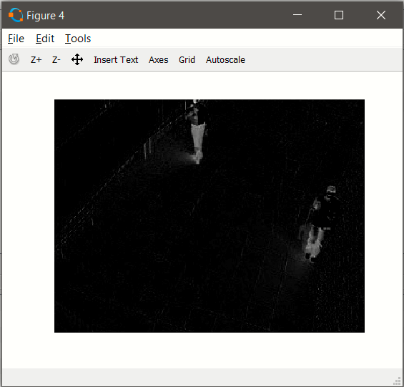

1. **Take your own black and white photo. Resize it to 256x256. Also consider given image 3.jpg. Demonstrate the logical operations like 'and', 'or', 'not' using these two images . Justify the results.**

* **Solution :-**

Code :

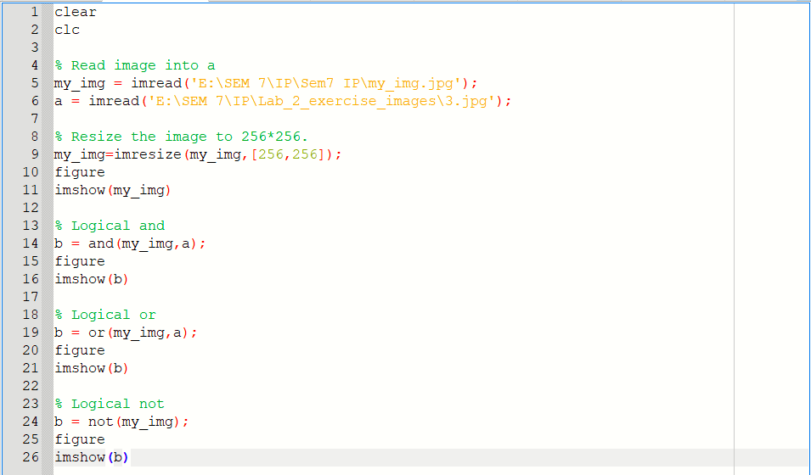

Output Images :

My Image

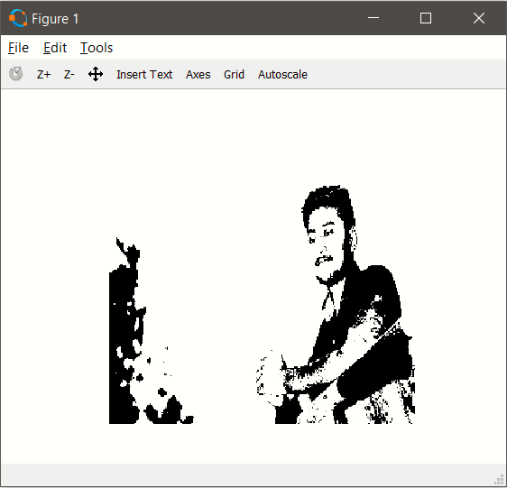

**Logical AND** : Logical And with 0 becomes 0 and others remains as it.

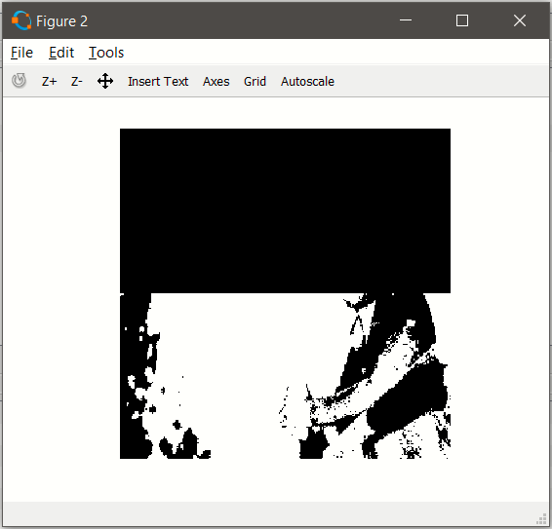

**Logical OR** : Logical Or with 1 becomes 1 and others remains as it.

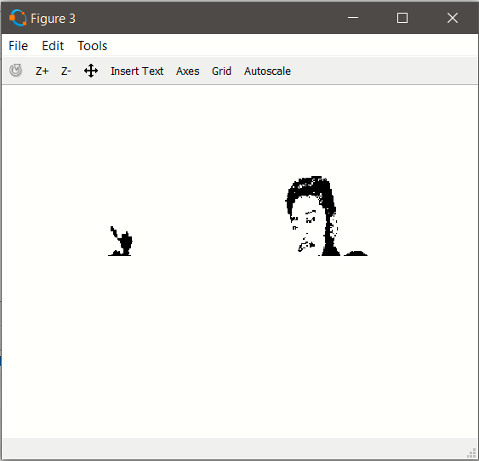

**Logical NOT** : Logical Not of 1 becomes 0 and 0 becomes 1.

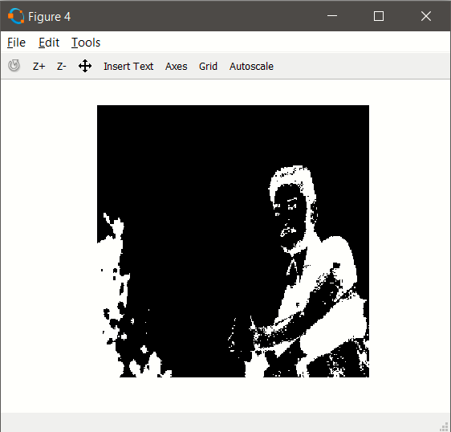

1. **Consider image 4.jpg, 5.jpg and 6.jpg as input and apply arithmatic operations on input image to generate 7.jpg as output image.**

* **Solution :-**

Code :

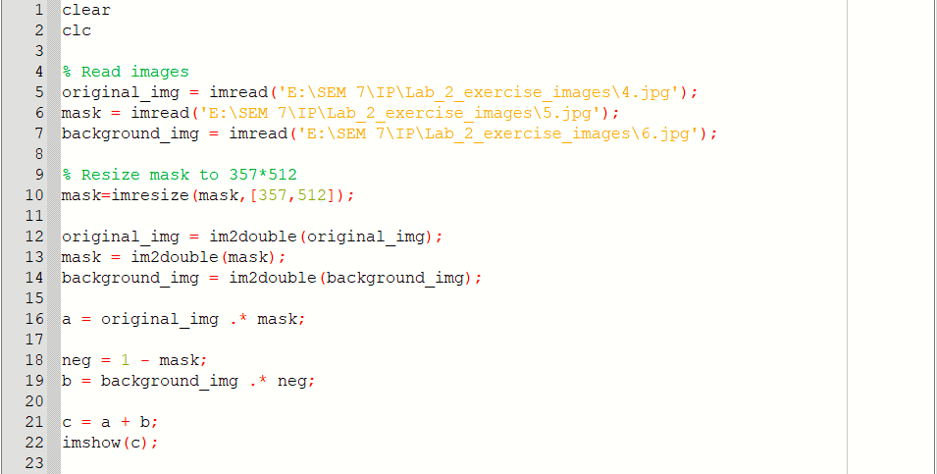

Output Image :

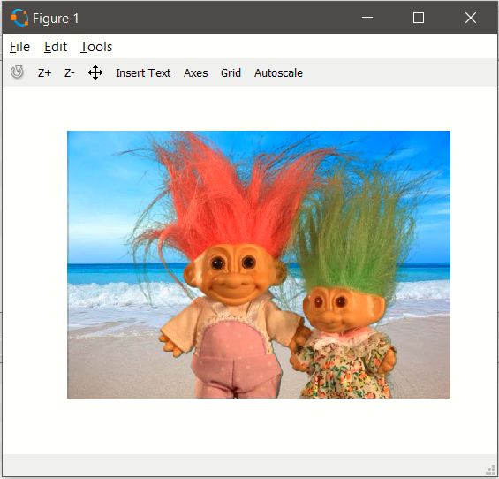

1. **Take your own grayscale photo and apply 'negative' transformation.**

* **Solution :-**

Code :

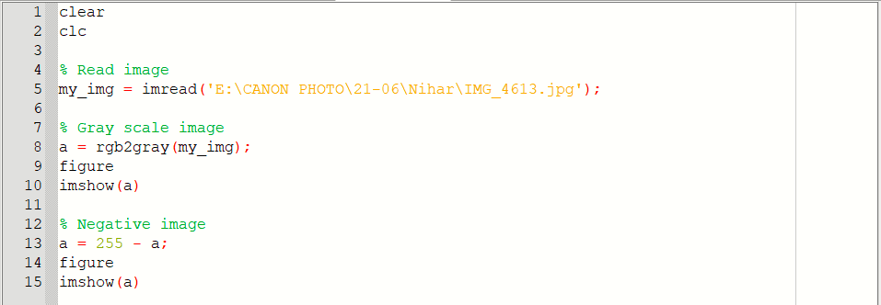

Output Images :

GrayScale Image

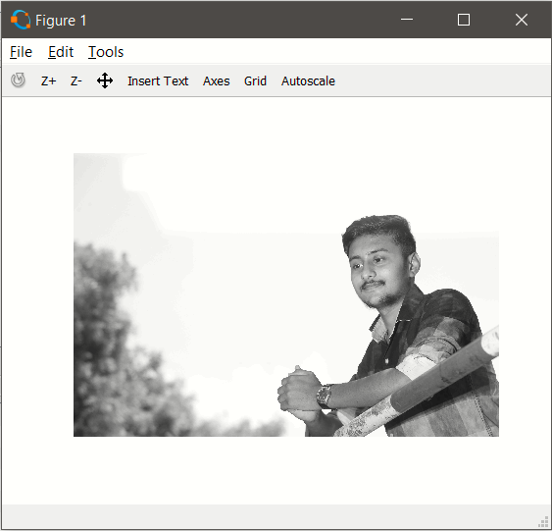

Negative Image



1. **Consider image 8.jpg. Enhance the image by applying the log transformation.**

* **Solution :-**

Code :

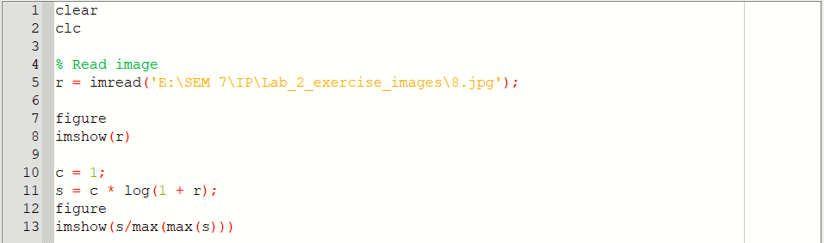

Input Image :

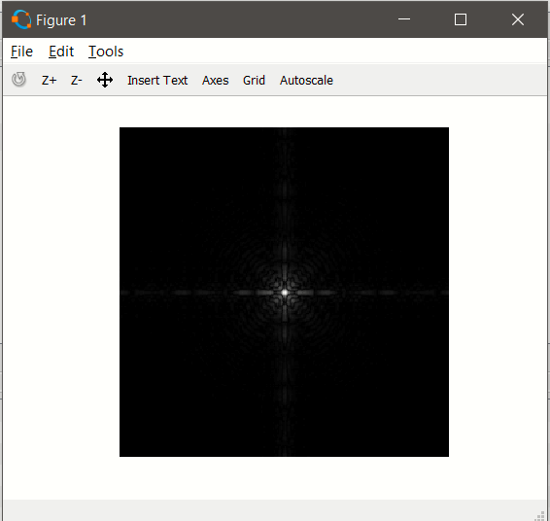

Output Image :

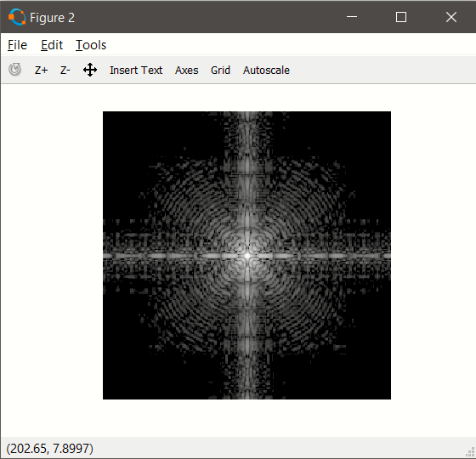

1. **Consider image 9.jpg and 10.jpg and enhance them with power law transformation.**

* **Solution :-**

Code :

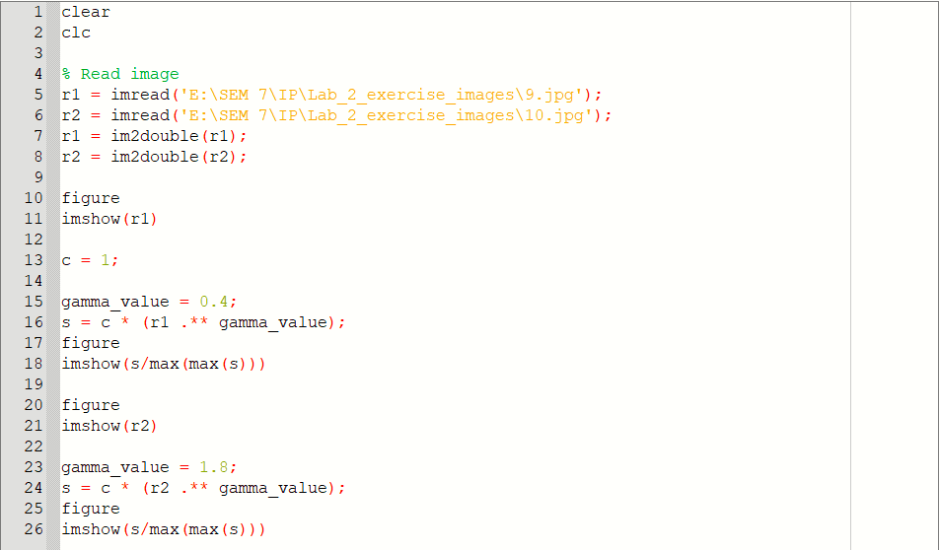

Input Images :

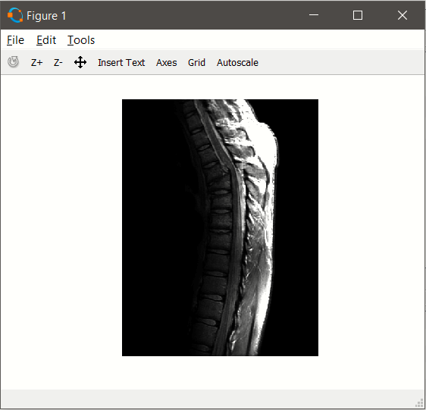

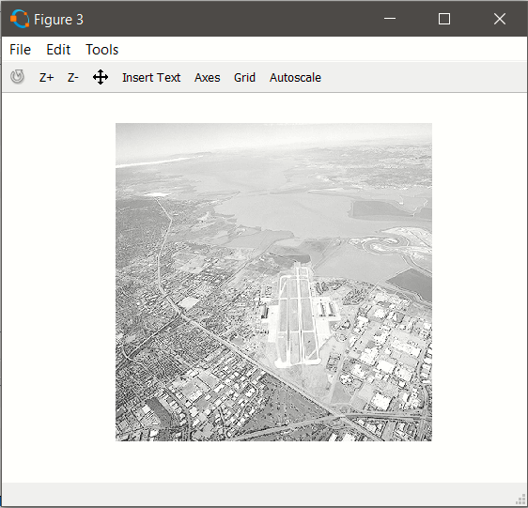

Output Images :

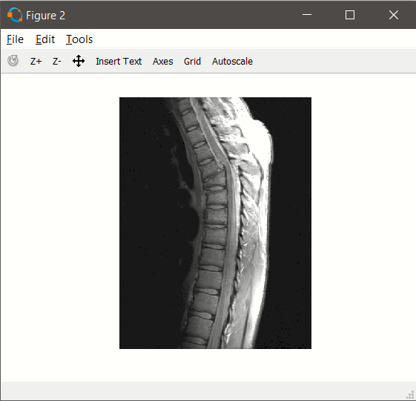

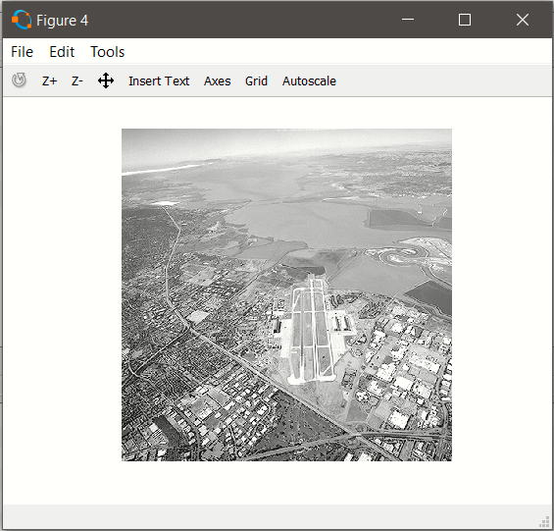

1. **Consider your over exposed photo(that you generated for assignment 1) and enhance it by power law transformation. Specify the value of gamma which is suitable for this enhancement.**

* **Solution :-**

Code :

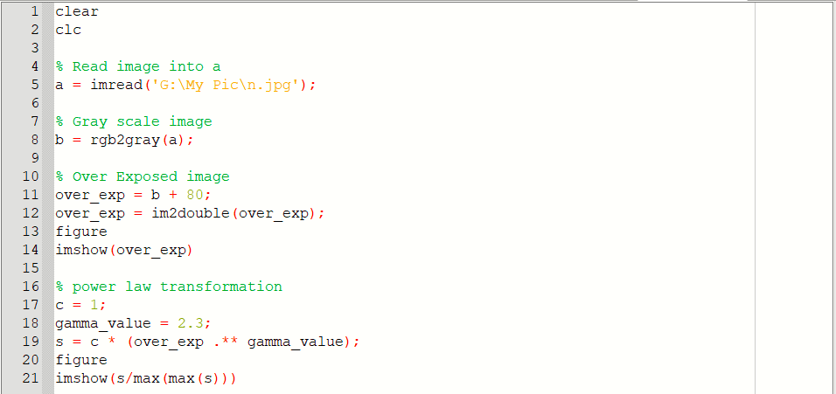

Input Image :

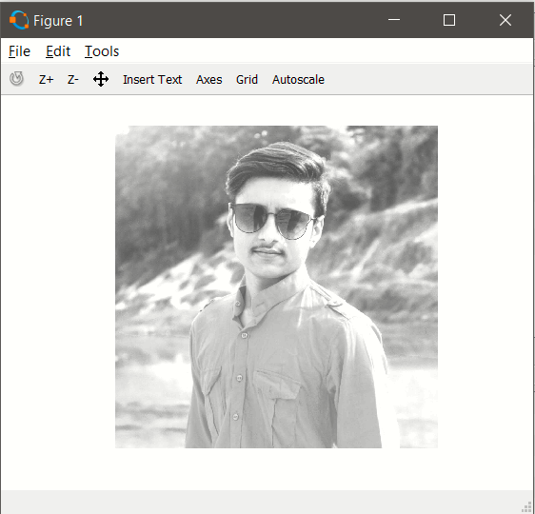

Output Image :

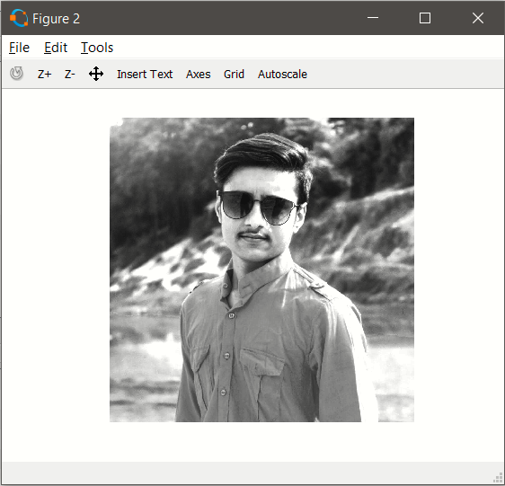

1. **Consider your under exposed photo (that you generated for assignment 1) and enhance it by power law transformation. Specify the value of gamma which is suitable for this enhancement.**

* **Solution :-**

Code :

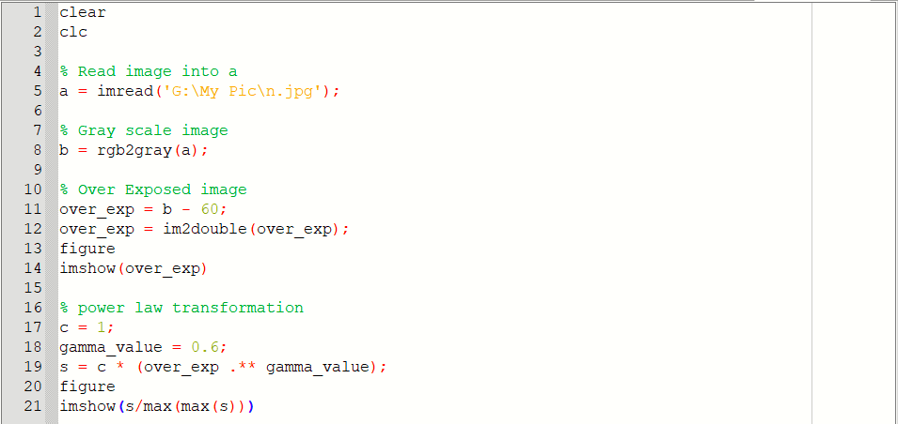

Input Image :

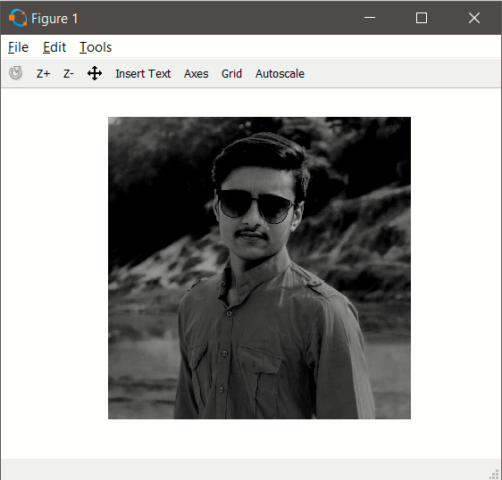

Output Image :

